|  |
| --- |
| **Exercise 3** |

Copy this file and open it in Word or some other editor that you can insert images.   
  
Be sure to read "How to Copy the Results of a Query" found in Module 2 in Canvas.    This is how you will be answering the following questions.  
  
Using the Class database, answer the following questions.

1. Write a query that will retrieve the quiz or test scores given on September 23, 2015. Display the student id, date, score, and category. Insert your screen shot here.

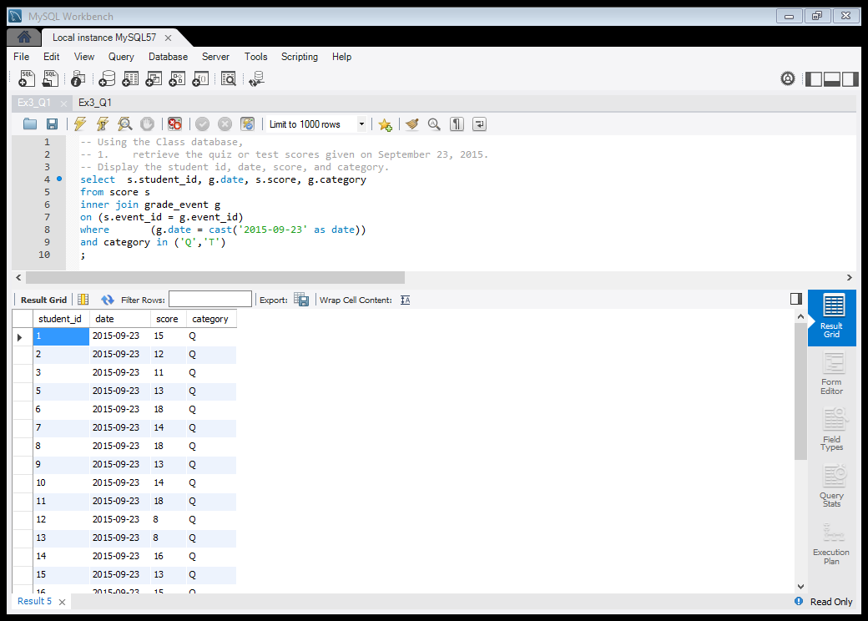

1. Display the student name, id, and date of the students who have missed class. Insert your screen shot here.

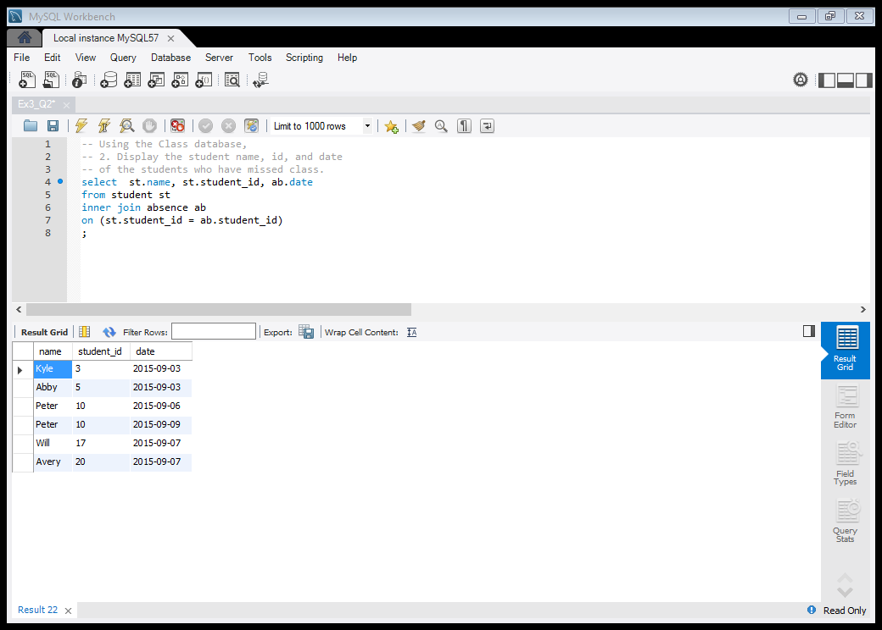

1. Using a join, display the student id number, name, event id, and score for student number 16. Insert your screen shot here.

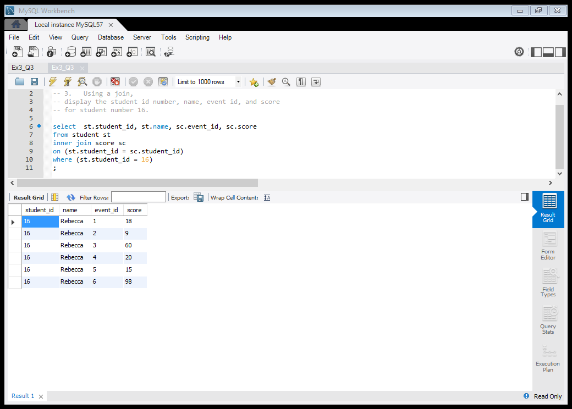

Using the Miscellaneous table, answer the following question:

1. Union the boys table with the girls table. Place the list in alphabetical order. Insert your screen shot here.

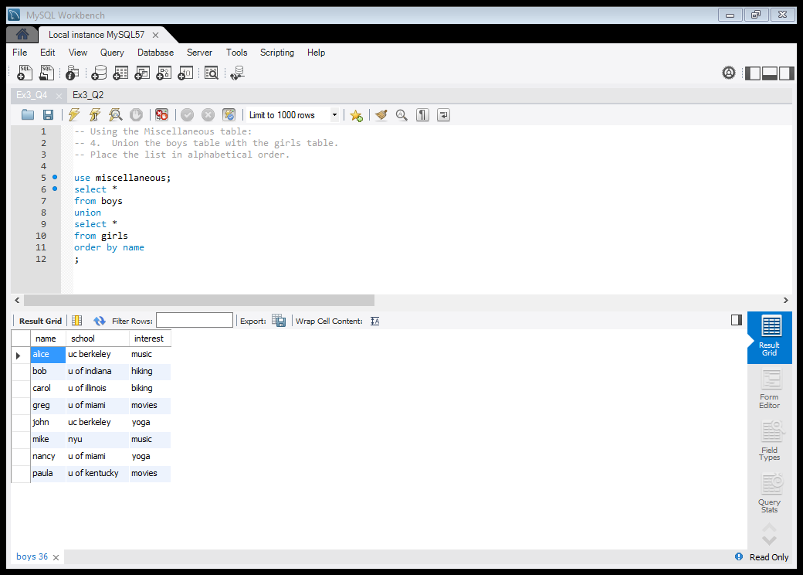

Using the Tennis database, answer the following questions.

1. Using a subquery, display the player numbers of the players who live in the same town as player 27. Let MySQL do the work for you. Do not explicitly query for the town of Eltham. Insert your screen shot here.

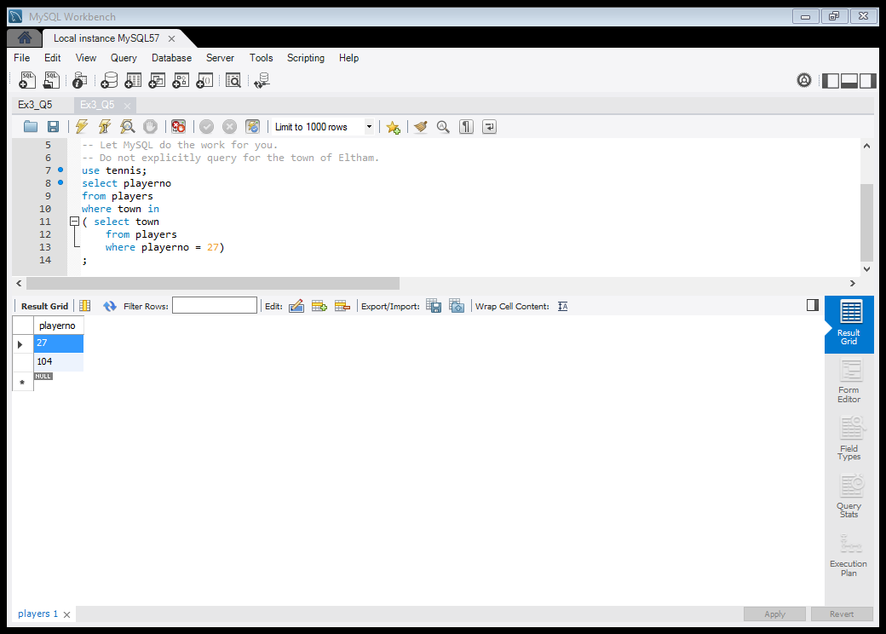

1. Using a subquery, display the name and player number of players who have served as Secretary. Insert your screen shot here.

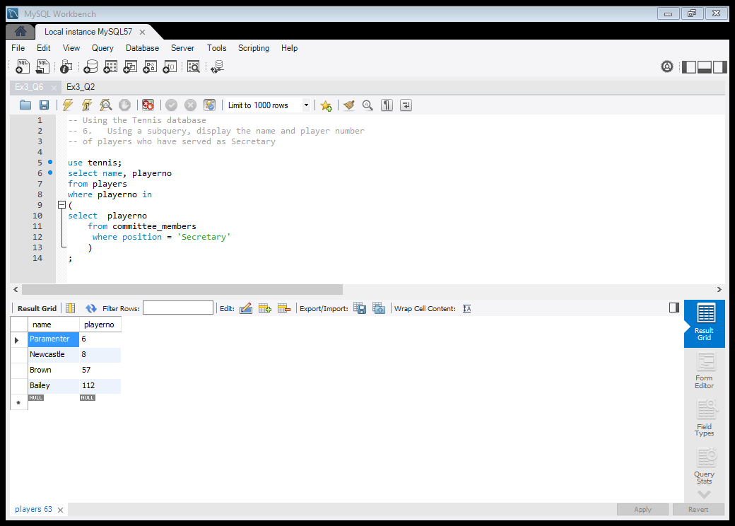

1. Display the numbers of the captains who have incurred at least one penalty. You can find the captains listed in the teams table. Insert your screen shot here.

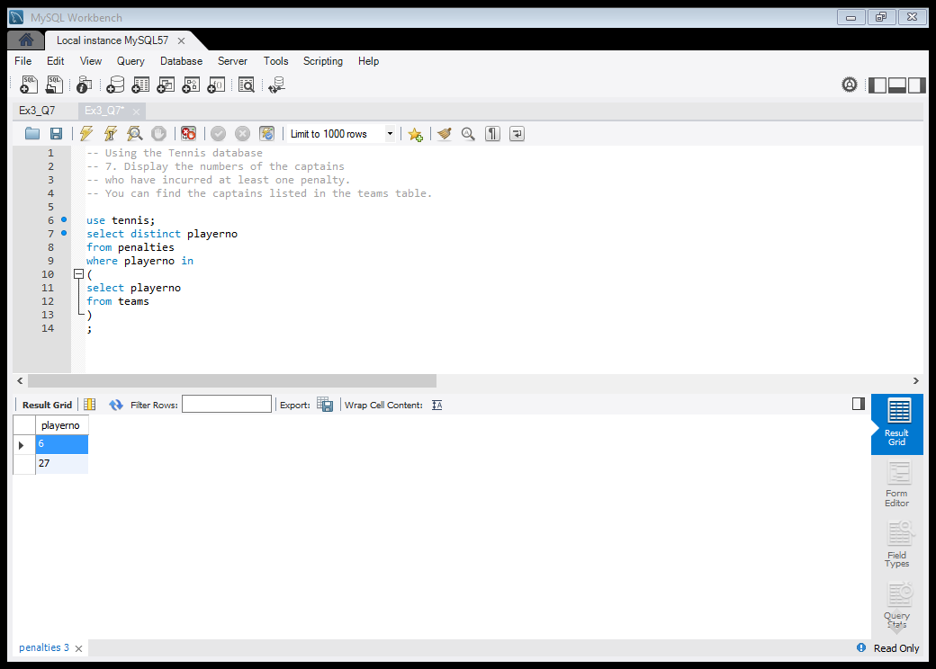

1. For *all* the players, display the player number, name, and the penalties incurred. Order the result by name. Insert your screen shot here.

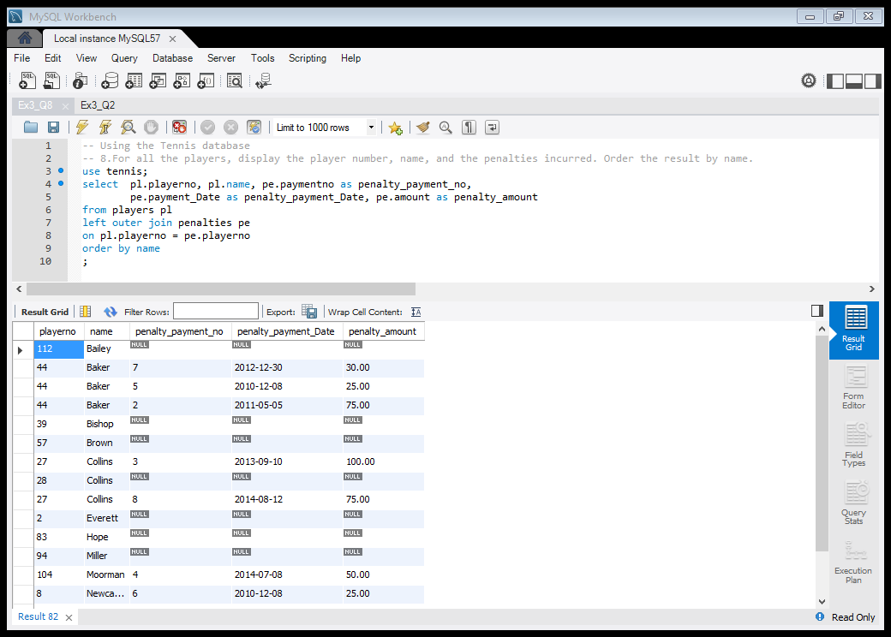

1. Using a union, display the number of each player who has incurred at least one penalty or who is captain, or for whom both conditions apply. In essence, union the penalties and the teams tables together. Order by player number. Insert your screen shot here.

